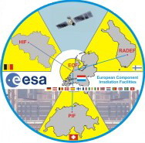
HIF – LIF Beam Time Request

Form to be sent to: Nancy Postiau
Centre de Ressources du Cyclotron (CRC)
Chemin du cyclotron, 2
B-1348 Louvain la Neuve
Belgium
Email: beam-booking@listes.uclouvain.be
FAX: ++ 32 / (0) 10 45 21 83

Date of the request:

Originator of the request:
Company:
Name:

Address:

Phone: Fax:
Email:

Invoice coordinates:
Name:

Address:

Phone: Fax:
Email:

Beam request:

Preferred irradiation period
Total number of hours needed for this irradiation campaign

Beam Type:
HIF: Heavy ions (High Energy Cocktail, M/Q = 3.33) - LET range from 1.3 to 62.5 MeV/mg/cm²

LIF: Protons (Energy range from 10 to 62 MeV)

